**System Configuration to execute RPA Bots**

**Document History**

|  |  |  |  |  |  |
| --- | --- | --- | --- | --- | --- |
| **Version** | **Release Date** | **Created By** | **Description of**  **Change** | **Genpact**  **Approval by** | **Customer**  **Approval by** |
| 1.0 |  |  |  |  |  |
|  |  |  |  |  |  |

**Terminology & Abbreviations used**

|  |  |
| --- | --- |
| IE browser | Internet explorer browser, compatible for AA bots |
| Display Settings | System Resolution should be well matched to execute the bot |
| RAM storage | The size of Read only memory which helps to increase the performance of the system |
| Process kill (.exe) | If any of the executable applications opens/running in the computer will be closed forcefully |

**TABLE OF CONTENT**

Table of Contents

Introduction 3

Overview 3

High Level Manual Process Description 3

Target Applications 3

Process Prerequisites 3

Definitions 4

Process Diagram - 5

System Configuration Description 6

Scheduling of Activities 10

User rights and access 10

# Introduction

This document provides a detailed and step by step understanding of ‘System Configuration’. These system setups are required for executing the Automation anywhere bot in the computer. Main purpose of this setup is that the bot must run in the machine successfully without getting any compatibility issues and able to identify the elements properly.

The purposes of the System Configurations are to:

1. Mainly system setup is used to execute the RPA Automation Anywhere bots
2. To identify or perform the actions on Internet explorer for bot execution, IE zoom size should be compatible.
3. The larger the size of RAM the faster the computer will operate. The RAM never runs out of memory; it continues to operate but just gets slower and slower.
4. It is important to keep the screen resolution based on bot compatibility. Because if the resolution is mismatches, there are huge chances the test will not execute properly

# Overview

## High Level Manual Process Description

1. Kill all the background running process (.exe files).
2. Check the IE browser zoom size is 100%.
3. In case the default IE zoom size is not 100, modify the zoom size into 100%.
4. Similarly check the screen resolution in Display settings. If the resolution is not 1366 x 768, update into the same.
5. Verify the Ram size is enough in machine to run the RPA bots and for a good performance. If the RAM is insufficient send an email to appropriate person.
6. Get the Computer name from system information.

## Target Applications

The following applications / systems are necessary to have access to, in order to the system configuration.

1. Internet Explorer
2. Display Settings
3. Screen Resolution
4. Outlook
5. Required .exe files

## Process Prerequisites

1. Administration Access
2. Access to Microsoft applications –Outlook

## Definitions

1. **Screen Resolution**

Screen resolution is the number of pixels a screen can show, both horizontally and vertically. So, a screen that has a resolution of 1920 x 1080 (a popular resolution that's also known as 1080p or Full HD), can display 1,080 pixels vertically, and 1,920 pixels horizontally. This is measured in PPI (Pixels Per Inch). We can change and modify the screen resolution as per our requirements (1366 x 768).

1. **RAM:**

RAM (Random Access Memory) is the hardware in a computing device where the operating system (OS), application programs and data in current use are kept so they can be quickly reached by the device's processor.

1. **Kill Process:**

We can kill all the processes running a specific. Windows already features a task manager that enables us to kill any active process

# Process Diagram -

Below is the high level process flow showing step by step movement of System configuration.

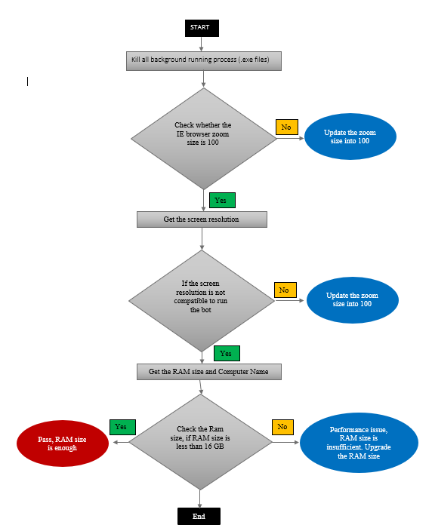

# System Configuration Description

Steps required to be followed for system setup:

1. Kill all the background running process (.exe files).

Fig: 1.1 Task Manager – will show all the running process

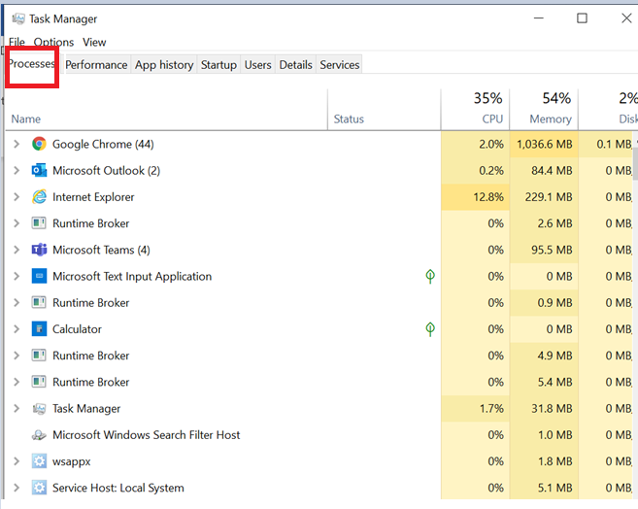

1. Open Internet Explorer

Fig: 2.1 IE



* + Click on the Settings option and navigate to Zoom size options.

Fig: 2.2 Zoom size tab

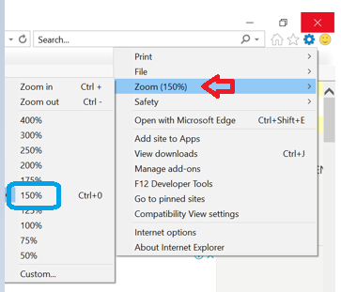

* + In case the default IE zoom size is not 100, modify the zoom size into 100%.

Fig: 2.3 Zoom size tab

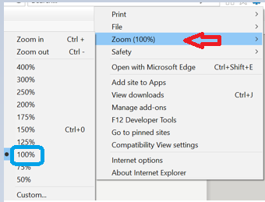

1. Open Display Settings to modify or verify the screen resolution

Fig: 3.1- Screen Resolution

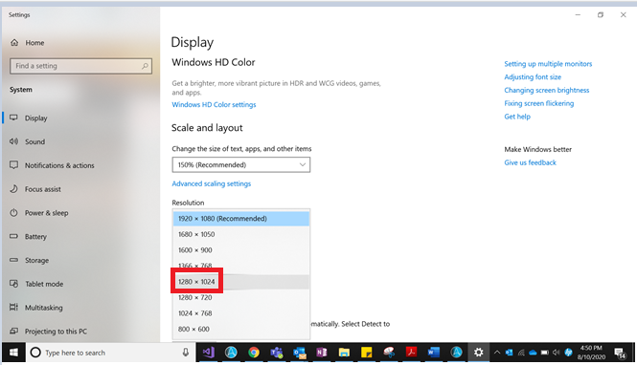

* + . If the resolution is not 1366 x 768, update resolution

Fig: 3.2- Compatible Resolution

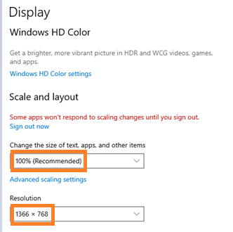

1. Verify the Ram size is enough in machine to run the RPA bots and for a good performance. If the RAM is insufficient send an email to appropriate person.
   * + Open control panel to navigate the System field

Fig. 4.1 – Control panel window

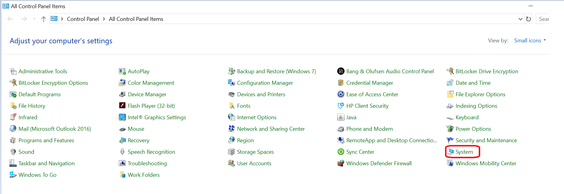

* + - Click on System to get the RAM size as well as Computer Name

Fig. 4.2 – System information

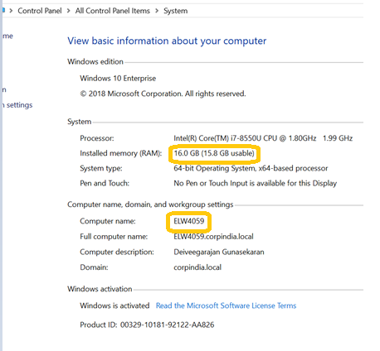

1. Send email to appropriate persons, if the RAM size is insufficient and it might have the performance issues.

Include the below details in email,

* + “Size of RAM”
  + “Computer Name”

Fig. 5.1 – Sample Email Template

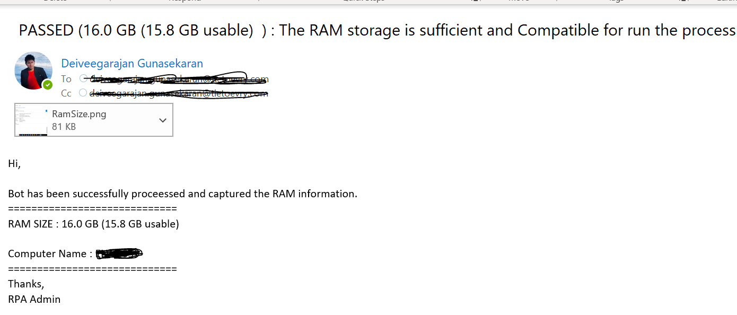

# Scheduling of Activities

The frequency of “System Configuration” is based on our requirements. If we need to do the setup on one-time setup, we can keep perform this setup. And, if we want the same setup to be executed each bot execution before running the scripts also it is possible to perform this setup.

# User rights and access

Mainly to setup the system, we need system administration privileges.